Latest hpx: benchmark： rotate_async.cpp

input size = 2^10- 2^27

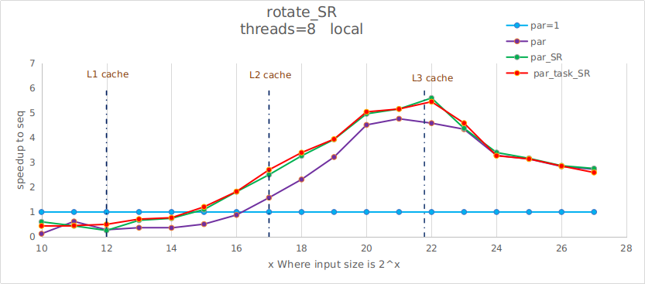

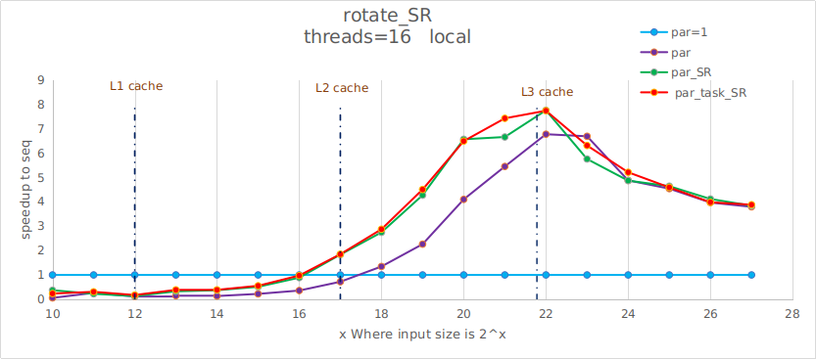

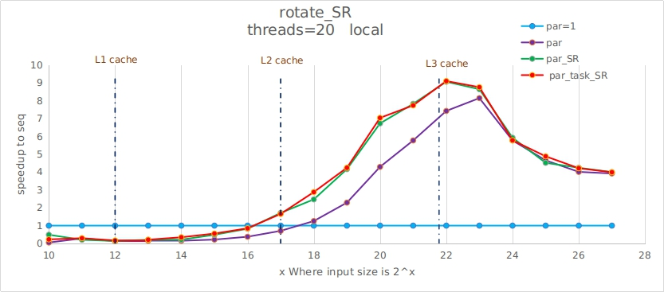

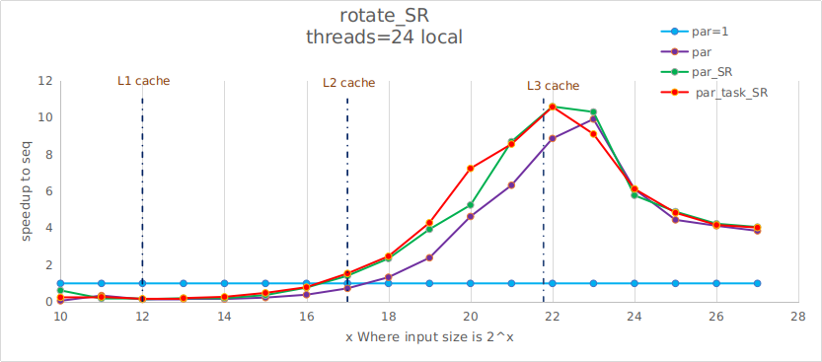

//

speedup with Threads increase

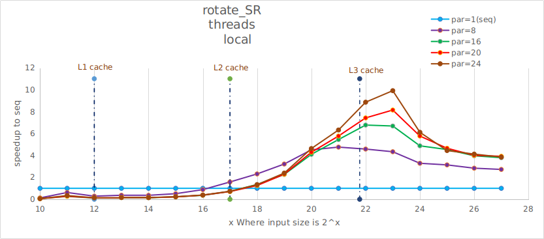

///////////////////////////////////////////////////////////////////////////////////////////////////////////////////////////

11.30

old benchmark: test new and old hpx

1. oldversion hpx on desktop:

chuanqiu@desktop:~/workhpx/hpx$ git checkout 4b087d4341b65e4ae8c5fa636a3978c8f45aaa1c

test log: https://gist.github.com/hcq9102/aa99242dcdf61f0485edf12f4389cb03

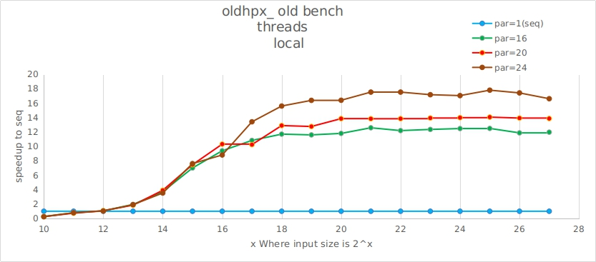

1. newversion hpx on desktop:

chuanqiu@desktop:~/workhpx/hpx$ git checkout fc73f749c0a949e67e780dd3b9c003a7a18292e7

test log: https://gist.github.com/hcq9102/aa99242dcdf61f0485edf12f4389cb03

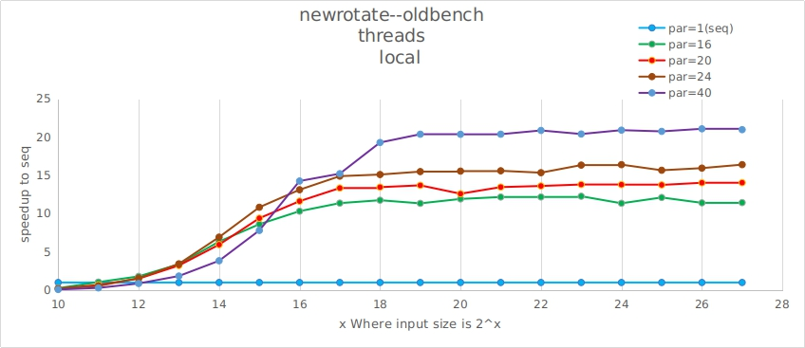

------------------------------------------------------------------------------------------------------------

input size = 2^10- 2^26

//

speedup with Threads increase

input size = 2^10- 2^26

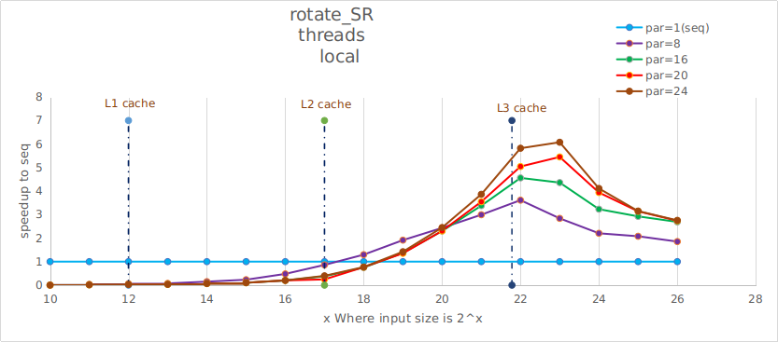

/////

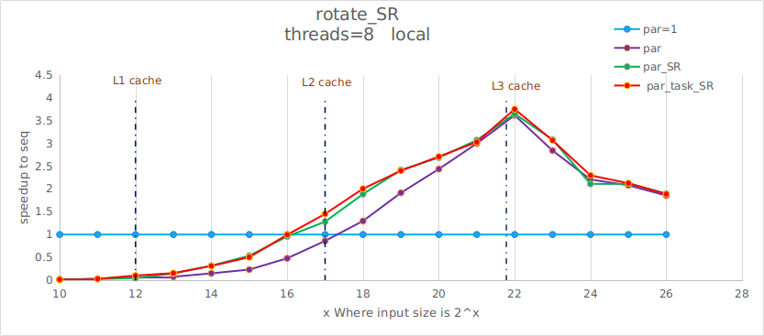

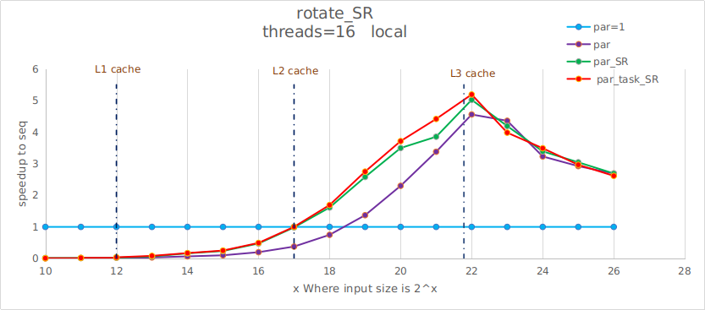

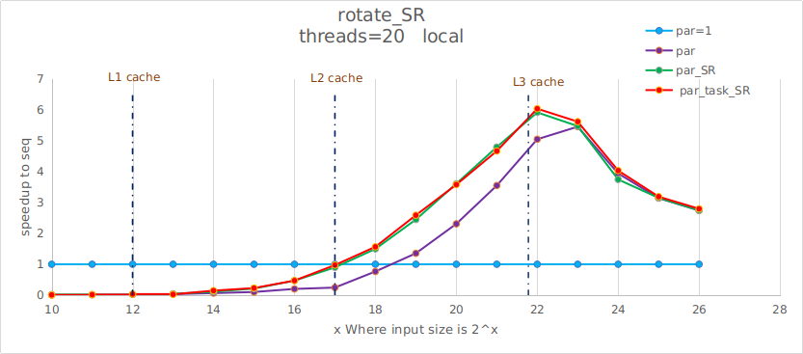

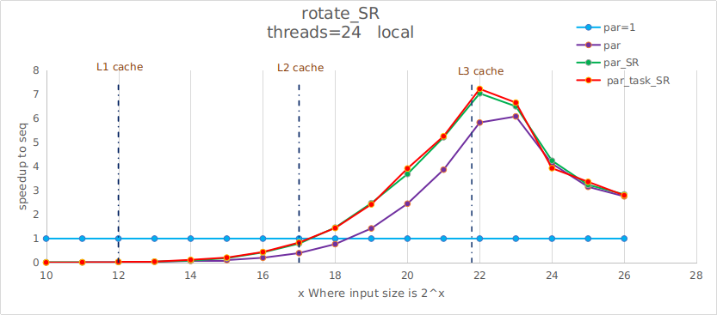

rostam:

old:

